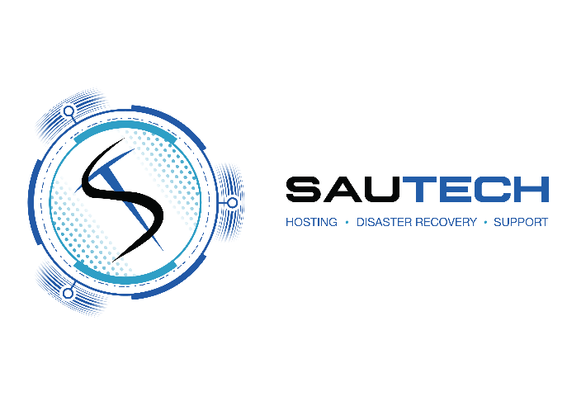

RSA Namibia
34 Stokroos Ave Regus
Breaunanda Maerua Mall, 3rd Floor
1739

Phone: 011 768 1790 Phone: +264 (0) 61 435 8232
Email: sales@sautech.net Email: sales@sautech.com.na
Reg No: 2003/006814/07 Reg No: 2023/0508
Vat No: 4240211963 Vat No: 13757380-015

ACCOUNT APPLICATION FORM:

Company / Individual Details

Full Company / Individual Name:________________________________________________________________

Physical Address: ___________________________________________________________________________

Office Number: _____________________________________________________________________________

Registration Number: ________________________________________________________________________

Vat Number: _______________________________________________________________________________

Representative Name: _______________________________________________________________________

Representative Email: ________________________________________________________________________

Account Authorised Personnel

Full Name and Surname: _____________________________________________________________________

Mobile Number: ____________________________________________________________________________

Office Number: _____________________________________________________________________________

Email Address: _____________________________________________________________________________

Primary (Technical) Contact Person

Full Name and Surname: _____________________________________________________________________

Mobile Number: ____________________________________________________________________________

Office Number: _____________________________________________________________________________

Email Address: _____________________________________________________________________________

Signed at _______________________ on this ________ day of ______________________ 20_____

____________________________ _____________________________
Print Name Designation

____________________________ _____________________________
Signature Witness

